Exe6—Intermediate Code Generation

1. 按照给定的语法制导定义，翻译下面语句。

if a>b then
while c>d do
d := d+1
else
x := y-z

语法制导定义1（第一版中文书P319，图8-23）
产生式 | 语义规则
S -> if E then S₁ | E.true := newlabel;
S -> if E then S₁ | E.false := S.next;
S -> if E then S₁ | S₁.next := S.next;
S -> if E then S₁ | S.code := E.code || gen(E.true ‘:’) || S₁.code
S -> if E then S₁ else S₂ | E.true := newlabel;
S -> if E then S₁ else S₂ | E.false := newlabel;
S -> if E then S₁ else S₂ | S₁.next := S.next;
S -> if E then S₁ else S₂ | S₂.next := S.next;
S -> if E then S₁ else S₂ | S.code := E.code || gen(E.true ‘:’) || S₁.code ||  gen(‘goto’ S.next) || gen(E.false ‘:’) || S₂.code
S -> while E do S₁ | S.begin := newlabel;
S -> while E do S₁ | E.true := newlabel;
S -> while E do S₁ | E.false := S.next;
S -> while E do S₁ | S₁.next := S.begin;
S -> while E do S₁ | S.code := gen(S.begin ‘:’) || E.code || gen(E.true ‘:’)  S₁.code || gen(‘goto’ S.begin)
S -> id:=E | p := lookup(id.name);  if p ≠ null then gen(p ‘:=’ E.place)  else error
E -> E₁ + E₂ | E.place := newtemp;  gen(E.place ‘:=’ E₁.place ‘+’ E₂.place
E -> E₁ - E₂ | E.place := newtemp;  gen(E.place ‘:=’ E₁.place ‘-’ E₂.place
E -> id | p := lookup(id.name);  if p ≠ null then E.place := p  else error
E -> num | p := lookup(num.value);  if p ≠ null then E.place := p  else error

语法制导定义2（第一版中文书P320，图8-24）
产生式 | 语义规则
E -> E₁ or E₂ | E₁.true := E.true;
E -> E₁ or E₂ | E₁.false := newlable;
E -> E₁ or E₂ | E₂.true := E.true;
E -> E₁ or E₂ | E₂.false := E.false;
E -> E₁ or E₂ | E.code := E₁.code || gen(E₁.false ‘:’) || E₂.code
E -> E₁ and E₂ | E₁.true := newlabel;
E -> E₁ and E₂ | E₁.false := E.false;
E -> E₁ and E₂ | E₂.true := E.true;
E -> E₁ and E₂ | E₂.false := E.false;
E -> E₁ and E₂ | E.code := E₁.code || gen(E₁.true ‘:’) || E₂.code
E -> not E₁ | E₁.true := E.false;
E -> not E₁ | E₁.false := E.true;
E -> not E₁ | E.code := E₁.code;
E -> ( E₁ ) | E₁.true := E.true;
E -> ( E₁ ) | E₁.false := E.false;
E -> ( E₁ ) | E.code := E₁.code
E -> id₁ relop id₂ | E.code := gen(‘if’ id₁.place relop.op id₂.place ‘goto’ E.true) || gen(‘goto’ E.false)
E -> true | E.code := gen(‘goto’ E.true)
E -> false | E.code := gen(‘goto’ E.false)

Answer：
（1）分析树
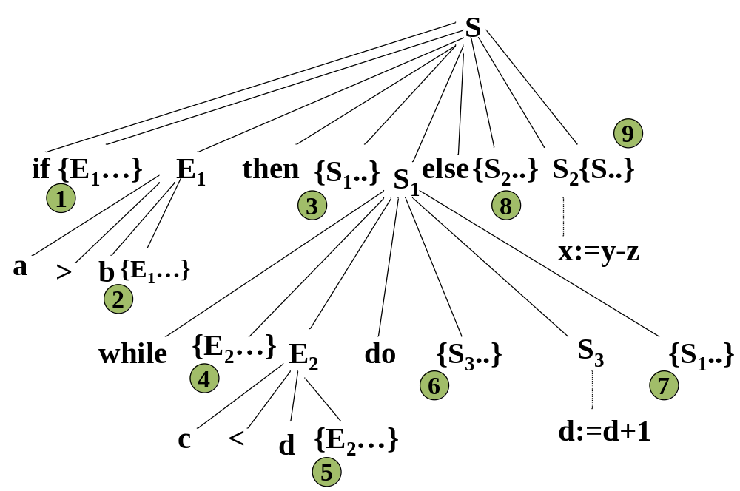

（2）中间结果
1、E1.true := L1
E1.false := L2
2、E1.code := { if a>b goto L1
goto L2 }
3、S1.next := S.next
4、S1.begin := L3
E2.true := L4
E2.false := S.next
5、E2.code := { if c>d goto L4
goto S.next }
6、S3.next := L3
7、S1.code := { L3 : (E2.code)
L4 : (S3.code)
goto L3 }
8、S2.next := S.next
9、S.code := { E1.code
L1: (S1.code)
goto S.next
L2 : S2.code }

（3）输出结果
结果: if a>b goto L1
goto L2
(L3) L1: if c>d goto L4
goto S.next
L4: t1:=d+1
d:=t1
goto L3
goto S.next
L2: t2:=y-z
x:=t2

